**Assignment – 1**

1. **Install Power BI Desktop and share the final screenshot of the report view page which appears when power desktop starts.**

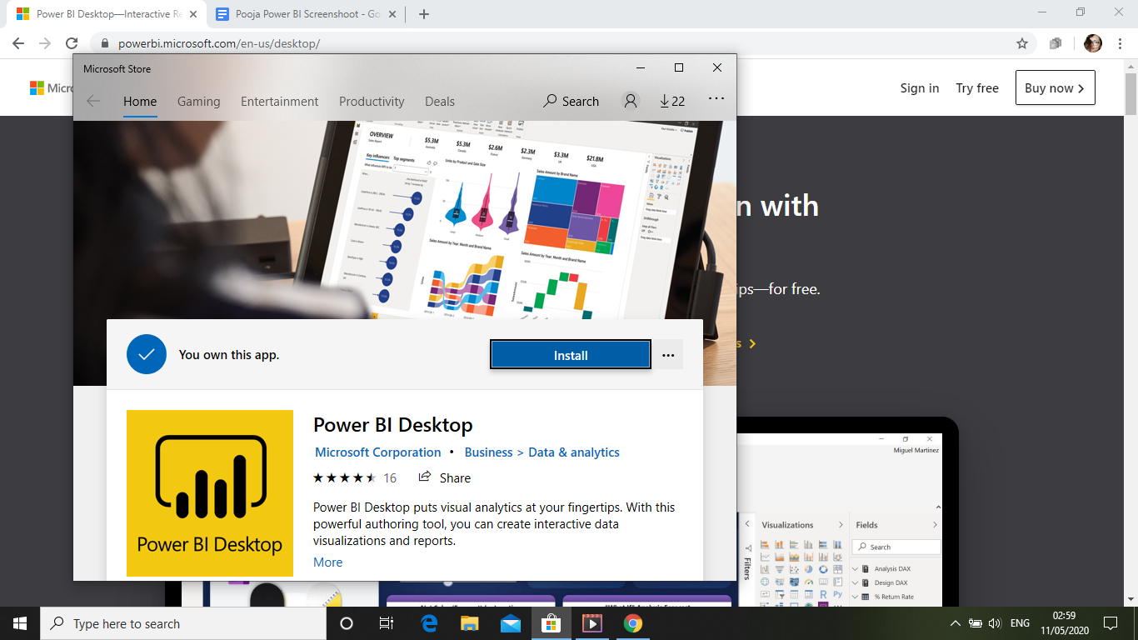

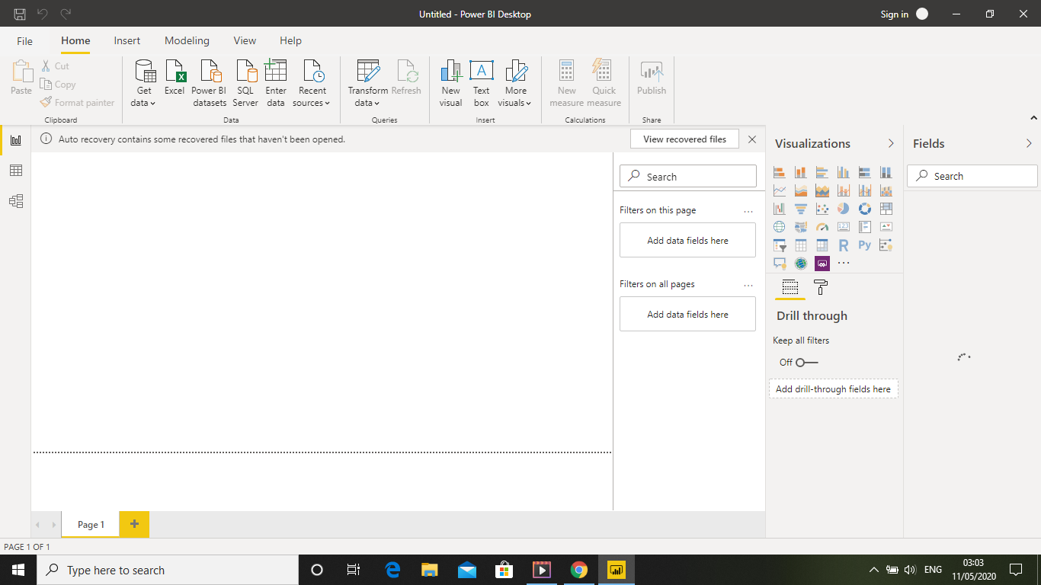

1. **Prepare a document and with the following screenshot**
2. **Report View**

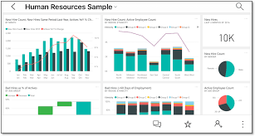

1. **Data View**

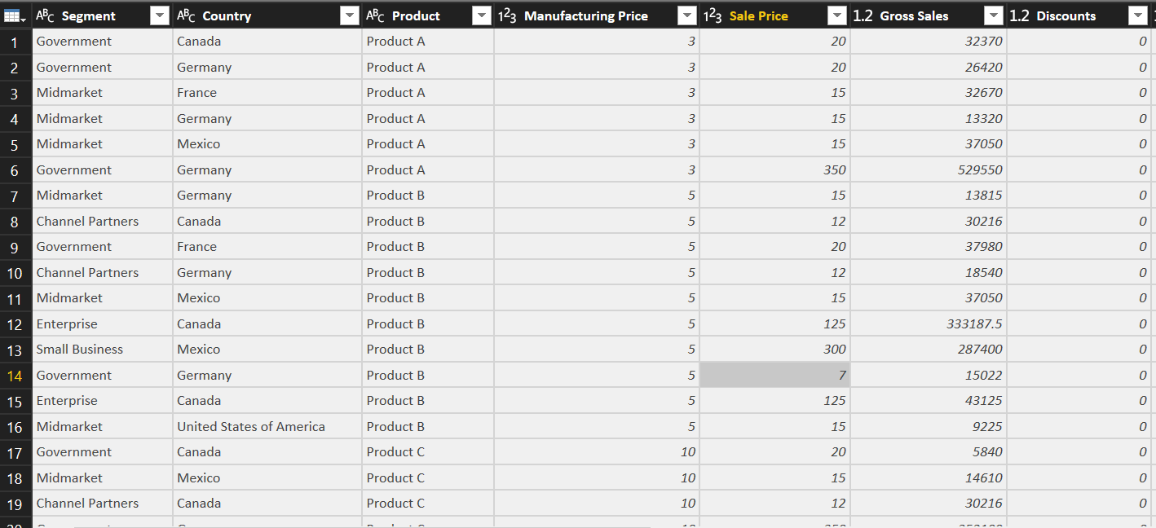

1. **Model View**

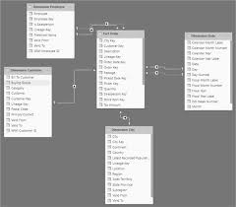

1. **Power Query Editor**

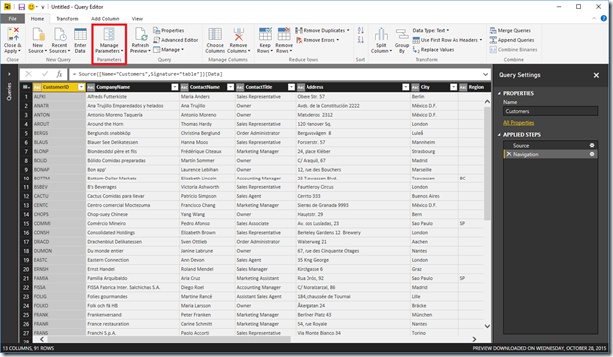

1. **Advance Editor**

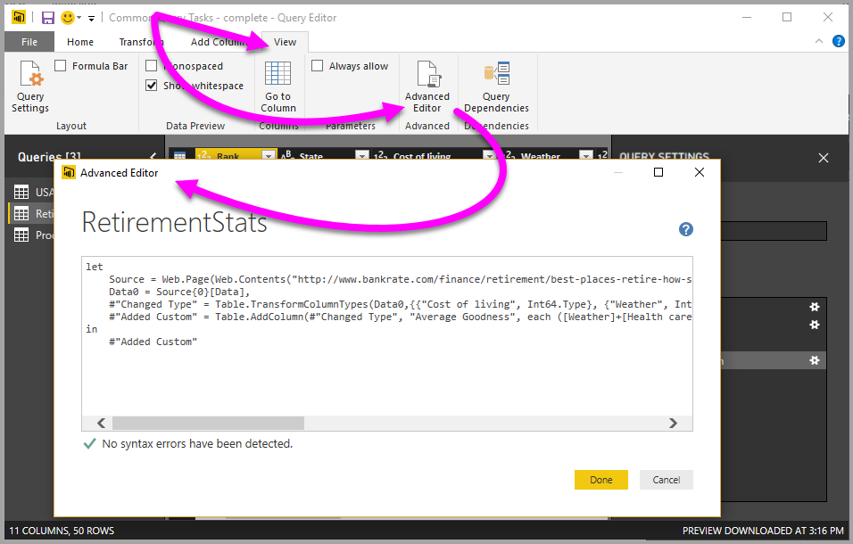

1. **Prepare a document with details of the following along with their price**

**A. Power BI Desktop:**

**Create rich, interactive reports with visual analytics at your fingertips—**

**for free**

**B. Power BI Pro:**

**Distribute and access insights anywhere by combining Power BI Desktop and Power BI Pro. Collaborate and build reports with colleagues and then publish and share those reports anytime, anywhere, and on any device.**

# **Power BI Pro :for £7.50 user/mont**

**C. Power BI Premium :**

**Enterprise BI, big data analytics, cloud and on-premises reporting**

**Advanced administration and deployment controls**

**Dedicated cloud compute and storage resources**

**Allows any user to consume Power BI content**

**Power BI Premium - 4,995 Per month**